EC2 Host Details

Ubuntu 20:04 as per assignment requirements:

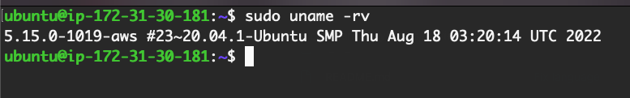

Docker Compose

All 3 containers running:



Front End is up:

Able to add movie:

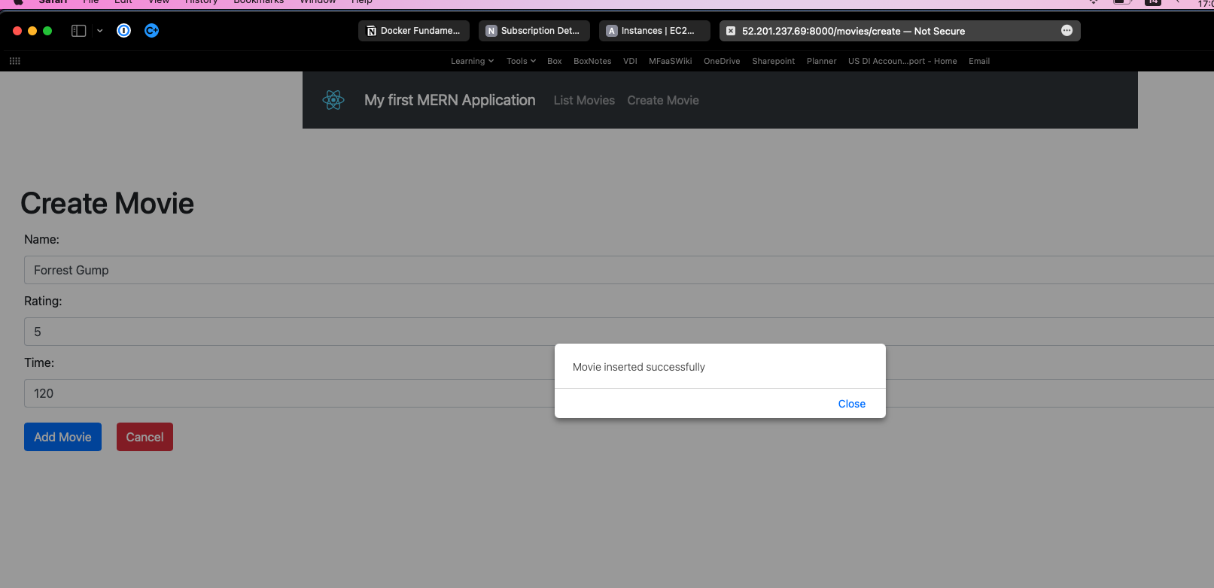

Able to list movies

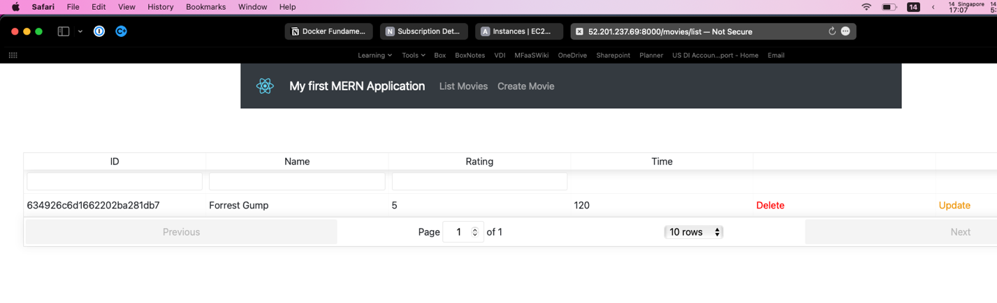

Able to update movies  
